Install GIT & make sure it is added into PATH.

Section 0 -Use GIT as local VCS. Steps to follow:

1. Create a directory ‘project_dir’ & cd to ‘project_dir’.

**mkdir project_dir**

**cd project_dir**

1. Initialize git version database. (git init)

**git init**

1. Create a new file index.html.

**touch index.html**

1. Check the git status. You should find index.html as untracked file.

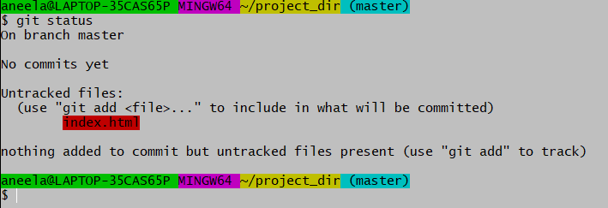

1. Stage the index.html file.

**git add index.html (or) git add** .

1. Commit index.html

**git commit -m “commiting index.html file”**

1. Make few changes in index.html & create a new file info.txt file.

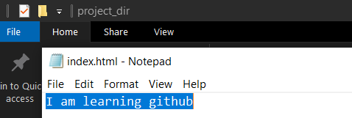

**touch info.txt**

1. Check git status. You should find index.html & info.txt as untracked files.



1. Configure GIT to ignore all txt files.

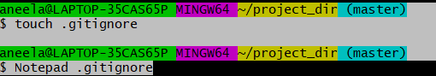

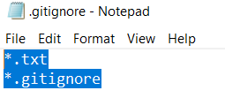

1. Again, check the git status. You should find only index.html as untracked file.

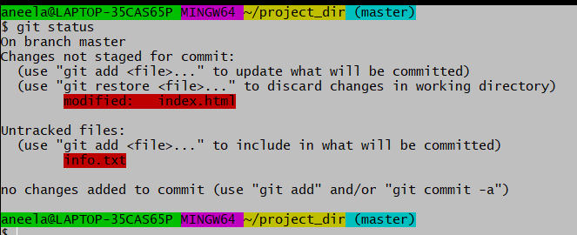

1. State & commit index.html

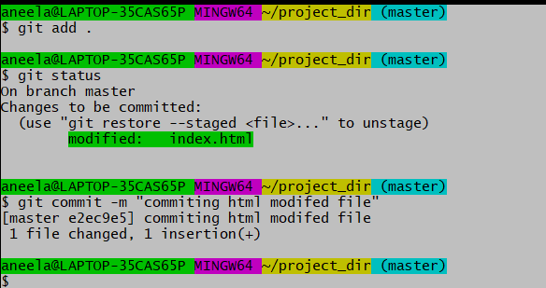

# 

1. Log all your comments so far.

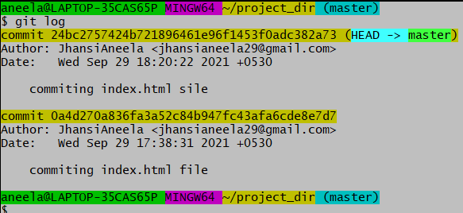

1. Make some changes in index.html.

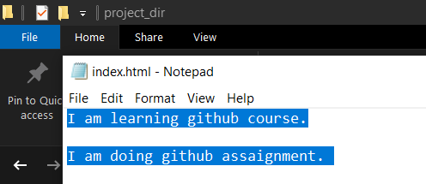

1. Revert the change made in the previous step using git command.

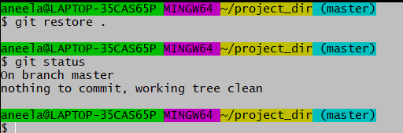

1. Again change index.html.

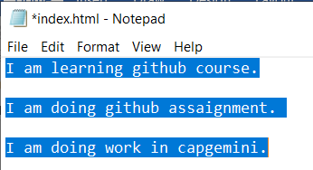

1. Stage index.html

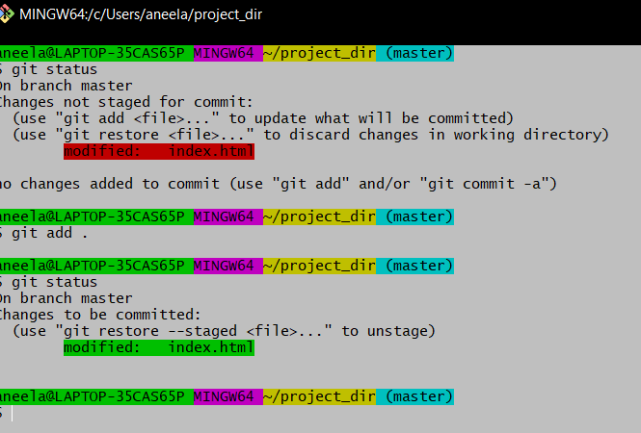

1. Revert back the last stage.

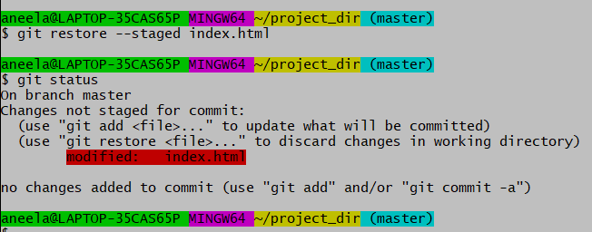

1. Rename ‘add’ command to ‘my-add’.

**Git config –global alias my-add add**

1. Using my_add command Stage index.html again & commit the changes.

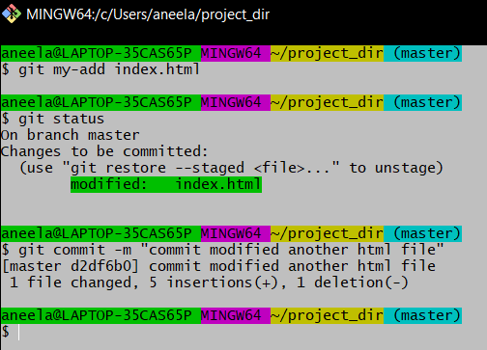

1. Revert the last commit.

git revert HEAD

*GIT Branching*

Objective: Commit HTML, CSS & JavaScript assignments into GIT.

SECTION-1 (HTML assignments) - Steps to follow:

1. First take a backup of your assignments & projects. This is required because due to incorrect GIT operation you may lose your files.

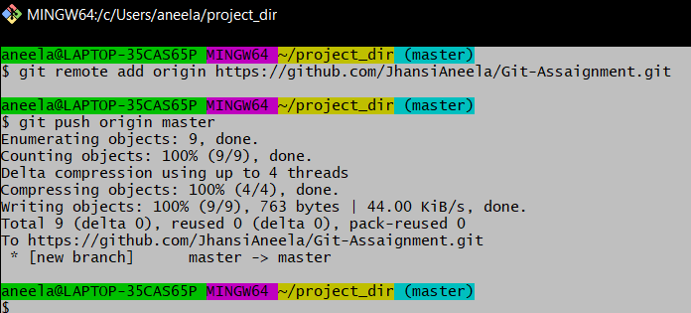

1. Create an empty directory ‘Assaignments’ & cd to ‘Assaignments’.

**mkdir Assaignments**

**cd Assaignments**

1. Create a file README.txt inside ‘Assignments’ & write few lines about the contents of ‘Assignments’ folder.

**touch README.txt**

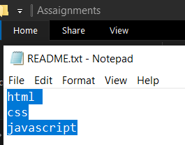

1. Commit README.txt file.

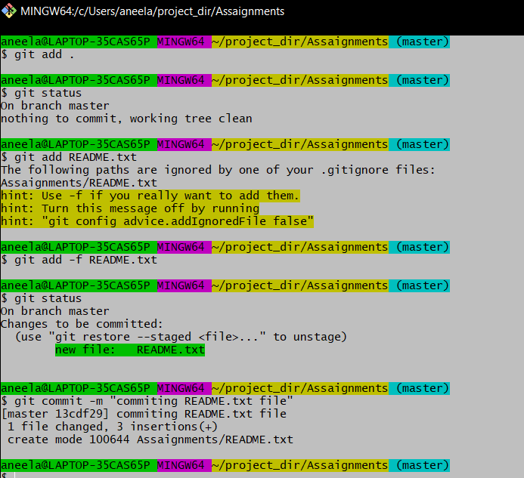

1. Now create a new branch ‘html-assignments’.

**git branch html-assignments**

1. Switch to ‘html-assignments’ branch.

**git checkout html-assignments**

1. Copy all HTML assignments inside ‘Assignments’ folder.

**touch a.txt**

**touch b.txt**

**touch c.txt**

1. Commit HTML assignments into ‘html-assignments’ branch.

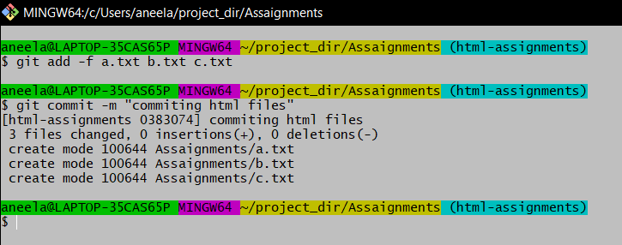

1. Make minor changes into few files belonging to ‘html-assignments’ branch.

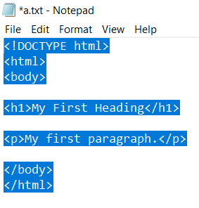

1. Commit those changed files.

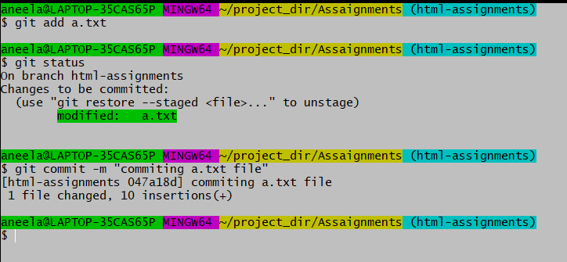

1. Switch to master branch.

**git checkout master**

1. Make minor changes into README.txt file & commit those changes into master.

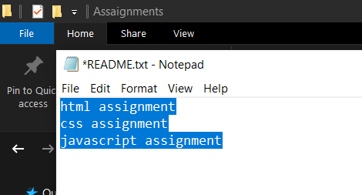

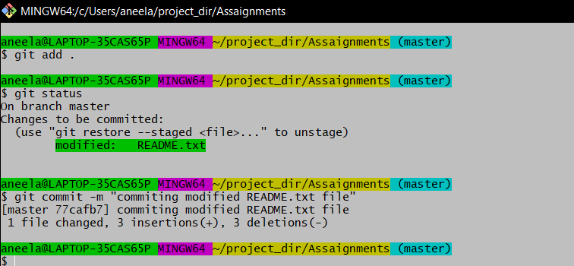

1. Again switch to ‘html-assignments’ branch.

**git checkout html-assignments**

1. Make minor changes into few files belonging to ‘html-assignments’ branch.

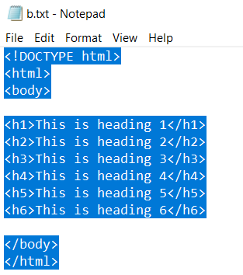

1. Commit those changes.

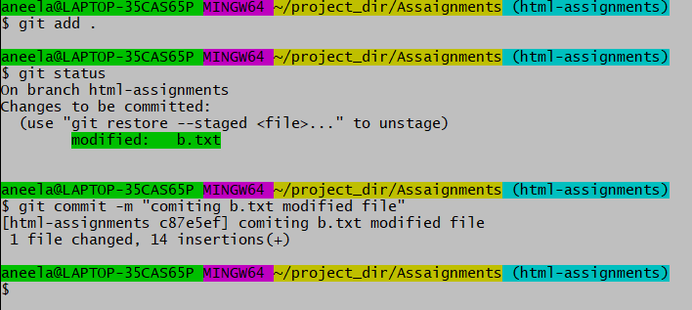

1. Switch to master.

**git checkout master**

1. Merge ‘html-assignments’ branch into master. Confirm all html assignments are shown in master.

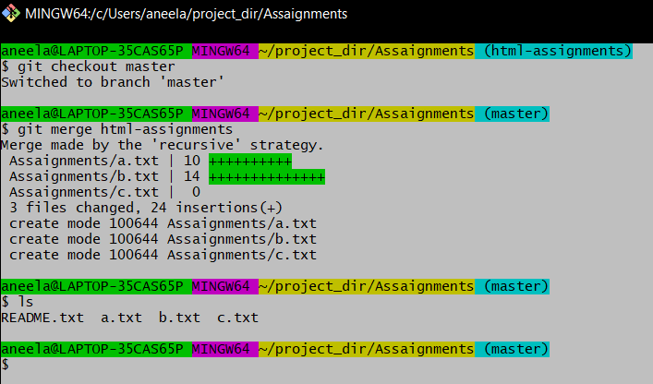

1. Finally delete the ‘html-assignments’ branch.

**git branch -d html-assignments**

SECTION-2 - (CSS assignments) Steps to follow:

1. Create a new branch ‘css-assignments’.

**git branch css-assignments**

1. Switch to ‘css-assignments’ branch.

**git checkout css-assignments**

1. Copy all CSS assignments inside ‘Assignments’ folder.

**touch demo1.txt**

**touch demo2.txt**

**touch demo3.txt**

1. Commit CSS assignments into ‘css-assignments’ branch.

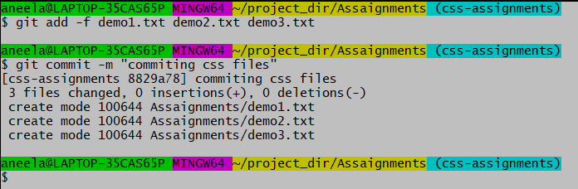

1. Make minor changes into README.txt file on line 1 belonging to ‘css-assignments’ branch.

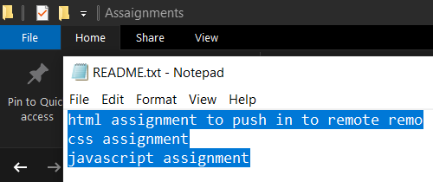

1. Commit those changed files.

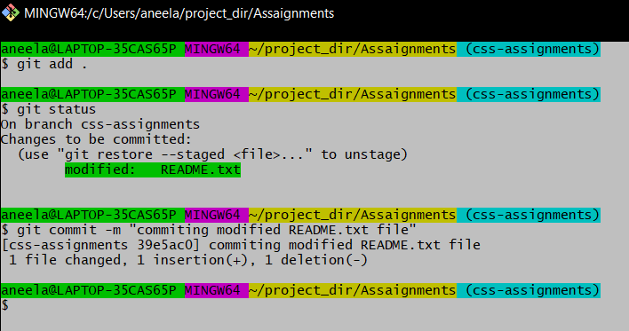

1. Switch to master branch.

**git checkout master**

1. Make minor changes into README.txt file on line 3 & commit those changes into master.

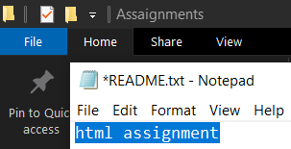

1. Again switch to ‘css-assignments’ branch.

**git checkout css-assignments**

1. Make minor changes into few files belonging to ‘css-assignments’ branch.

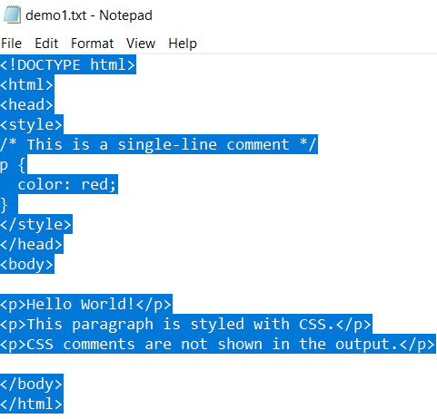

1. Commit those changes.

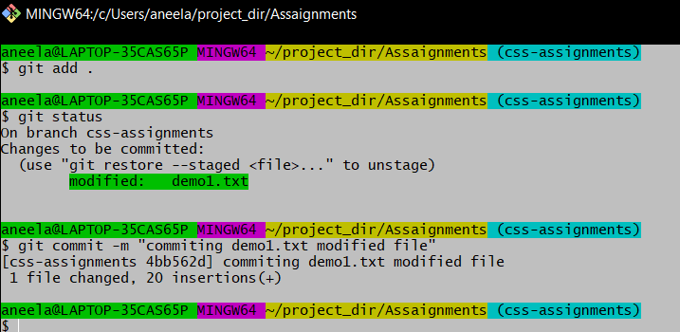

1. Switch to master.

**git checkout master**

1. Merge ‘css-assignments’ branch into master. Confirm all css assignments are shown in master.

**git merge css-assignments**

1. Finally delete the ‘css-assignments’ branch.

**git branch -d css-assignments**

SECTION-3 - (JavaScript assignments) Steps to follow:

1. Create a new branch ‘js-assignments’.

**git branch js-assignments**

1. Switch to ‘js-assignments’ branch.

**git checkout js-assignments**

1. Copy all JavaScript assignments inside ‘Assignments’ folder.

**touch m1.txt**

**touch m2.txt**

**touch m3.txt**

1. Commit JavaScript assignments into ‘js-assignments’ branch.

**git add -f m1.txt m2.txt m3.txt**

**git commit -m “comiting js files”**

1. Make minor changes into README.txt file on line 1 belonging to ‘js-assignments’ branch.

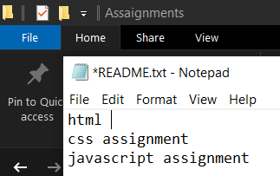

1. Commit those changed files.

**git add .**

**git status**

**git commit -m “commiting modified README.txt file”**

1. Switch to master branch.

**git checkout master**

1. Make minor changes into README.txt file on line 1 & commit those changes into master.

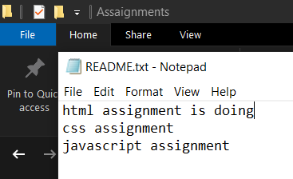

1. Again switch to ‘js-assignments’ branch.

**git checkout js-assignments**

1. Make minor changes into few files belonging to ‘js-assignments’ branch.

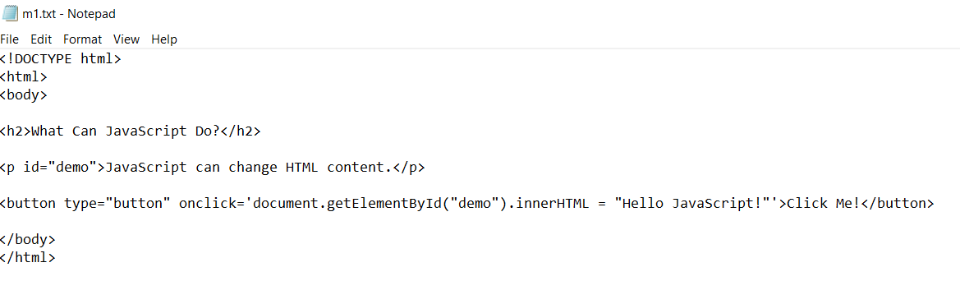

1. Commit those changes.

**git add .**

**git status**

**git commit -m “commiting modified m1.txt file”**

1. Switch to master.

**git checkout master**

1. Merge ‘js-assignments’ branch into master. Confirm all JavaScript assignments are shown in master.

**git merge js-assignments**

1. Finally delete the ‘js-assignments’ branch.

**git branch -d js-assignments**

*GIT Remoting*

Objective: Pushing source code into GITHUB & collaborate team members.

SECTION-3 (Pushing assignments to remote repository) - Steps to follow:

1. Create a github account if you do not have already.

**Already Created**

1. Login on into github account.
2. Create new public repository ‘freshersbatch-oct16’.

**Open new repository and create freshersbatch-oct16**

1. Commit & push any sample file to this repository under ‘Assignments’ directory.

**git add .**

**git status**

**git commit -m “commiting modified C.txt file”**

SECTION-4 (Pushing source code to remote repository using Eclipse GIT plugin) - Steps to follow:

1. One developer from project team will create eclipse projects ‘SampleProj’ & add sample source code files. Then commit all files through eclipse GIT plugin.
2. Collaborate other team members with your github account so that they can also modify the committed files.
3. Other developers from same team will checkout all files from remote repository. This might get conflicts since certain files fail to merge. In such case, merge it manually.
4. Commit & push the ‘SampleProj’ project.